
This guide covers the steps you need to register yourself, your school and your groups in order to make an online presentation in the results section. If you follow the steps below, this is very easy.

To make your school or group results

This process can be done by following the ‘Configure groups’ link from the results page. Only one teacher is needed per school to register. You can add as many groups as you wish per school by giving them a different name and password.
When you make a group, write down the name of the group and password and you can share this with your students for them to make their own group presentation.

Registering
1. Go to the result page and click on ‘Configure groups’.

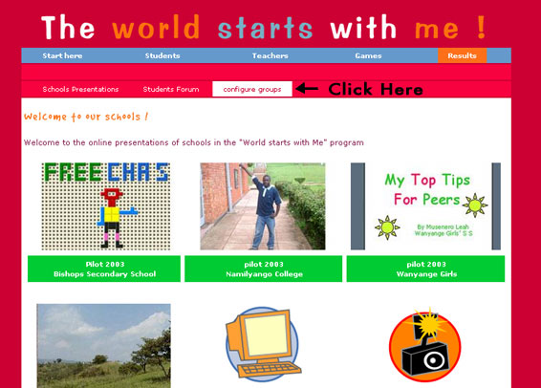

2. Follow ‘this link’ the first time you want to register.

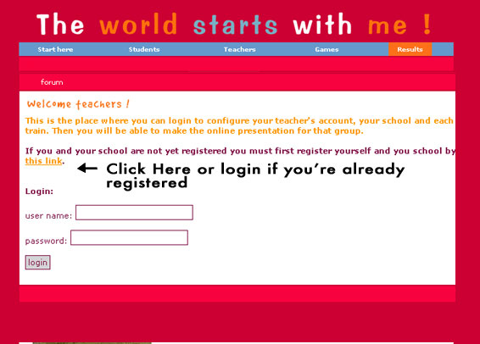

3. Add the name of your school and click on ‘Make’ to add a new school to the list.

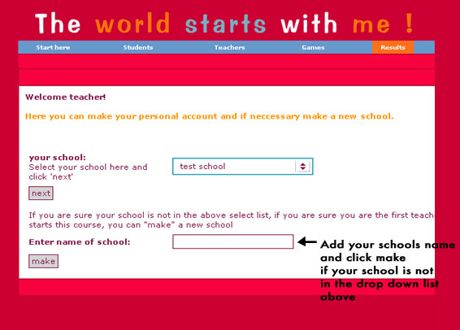
4. Now your school has been added, you need to register yourself as a teacher at this school.

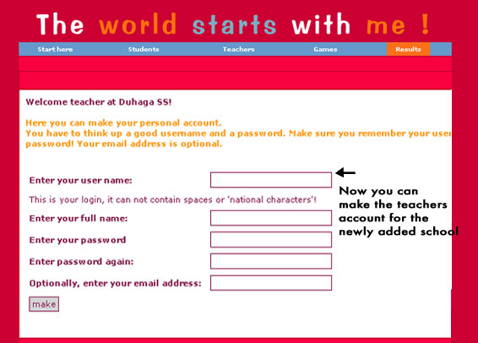

5. Now that both your school and you have been registered, you can log in and create groups for your school, giving them their own password.

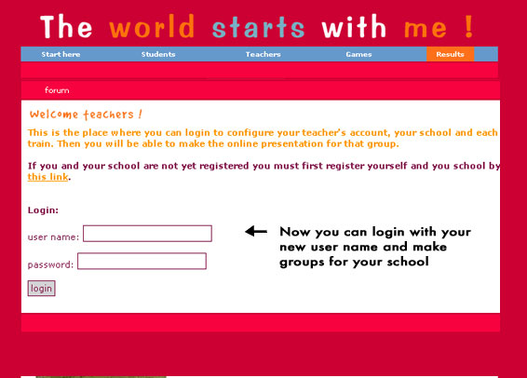

6. You can add as many groups as you like. Give each one a different name and password so each group can then make its own presentation under results.

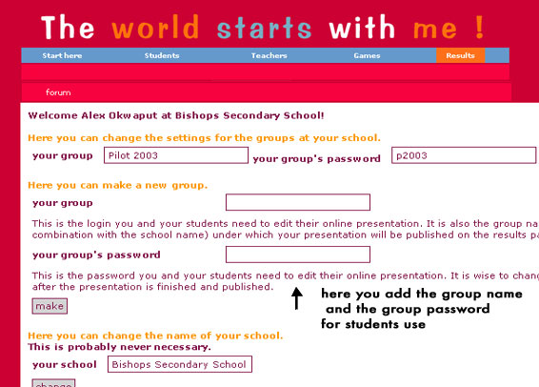

7. Now you can go to the groups page via the results page and then click on ‘Schools’ presentations’.

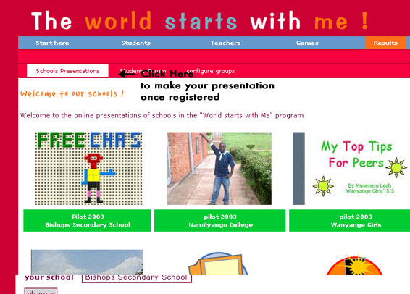

8. Now choose your group from the drop-down menu and log in using the password.

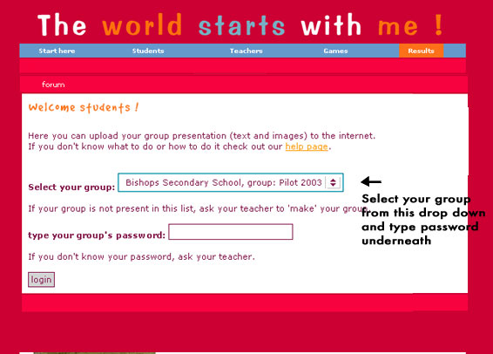

Last but not least
If you have any further questions please mail: wswm@wpf.org

