0/5 - Computer Skills: Surfing the Internet

HANDOUT: WORLD WIDE WEB
Internet introduction | The Internet is a worldwide network that connects millions of computers to each other. It was started as a project of the United States Department of Defense and Universities in the 1960s, and has grown in the past ten years into a global network that allows people from all kinds of backgrounds to communicate with each other using their computers. The Internet provides several different services to its users, some of which will be described below.
The World Wide Web | Part of the Internet is the World Wide Web (or "WWW", "The Web"). This WWW consists of information that is available on computers in the form of "Websites". A website is basically a collection of pages (also called "web pages") of information including text, pictures and other elements that are written in such a way that it can be reached and read from other computers that are connected to the Internet. A typical website can look as follows.
To be reached, a website needs to have an address called a "Uniform Resource Locator" or URL, that looks similar to the following: http://www.nairobits.com/
When you see such an address in a document or on a web page, it is often underlined and is then called a Hyperlink or simply Link, because it will link you to that web page when you click with your mouse on it. Often, the link only consists of an underlined piece of text or a picture that can be clicked on are all hyperlinks. Note that hyperlinks may change their colour once you have clicked on them. This is for you to remember that you have visited that page before. In the above Figure, the Purple links are all visited, the Blue link is not visited yet.
Search engines | It is often not easy to find the information you want on the WWW. There is no such thing as a directory available to locate what information can be found where. However, there are web pages that can locate information for you. These web pages are called "Search Engines". In a search engine, you simply fill in what information you want to find on the WWW and it will come back with a list of URLs that contain that information. See below for an example from Google, which is one of the best search engines.
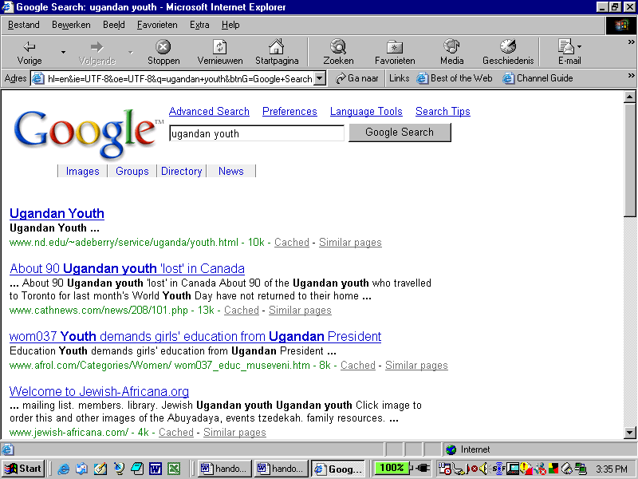
Figure 11-2. The Google Search Engine with results for a query on "Ugandan youth".

 | Navigating on the Web using these kind of links is also called "Websurfing", "Surfing the Internet", "Surfing the Web" or "Web browsing". The software you are using to surf on the Web (and that the two figures above are taken from) is called a "Web browser".
News | Another service on the Internet is News. News consists of thousands of "Newsgroups" that are similar to E-mail Inboxes, but are different in the sense that they can be reached by all people on the Internet at the same time and you can send messages similar to E-mail to newsgroups that all those people can read and respond to. A typical newsgroup looks like this:
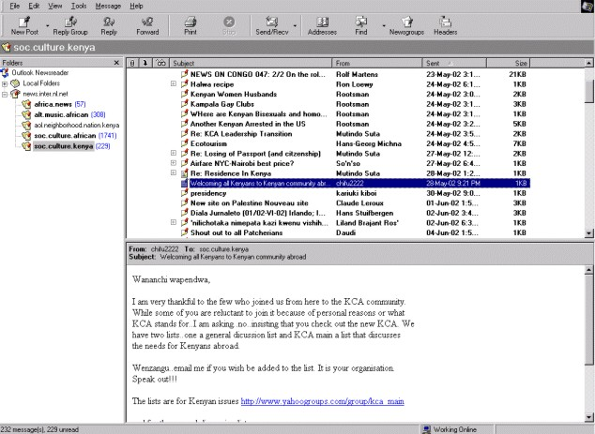
Figure 11-3. News
 | In Figure 11-3, you can see on the left hand side five newsgroups that I subscribed to (Africa. news, alt.music.african, etc.). One of these newsgroups is now selected: soc.culture.kenya. On the right hand side, you can see the messages contained in this newsgroup. As you can see, they are similar to e-mails. However, with News, you can reply to the newsgroup (so that everybody can read your reply message) or only to the person who sent the original message.
Chat rooms | Chat rooms are websites in which you can communicate directly with many other people, as if you are having a phone call with multiple people. The difference is, that you are writing messages to each other instead of talking to each other. Below is an example of a Chat room.
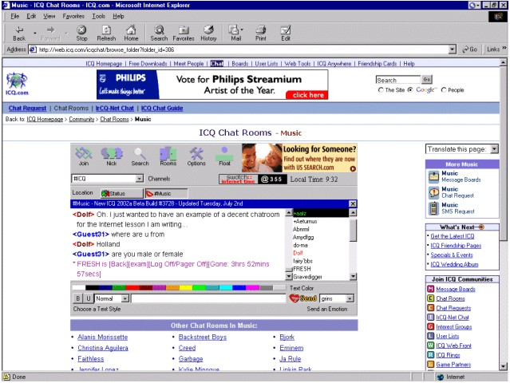
Figure 11-4. A Chat room
 | In the screen above, you see a chat conversation between two users, -Dolf- and -Guest31-, in the middle section. Just right of that section, you see a list of other users that are also present, but are not taking part in the conversation now. Around it are a whole lot of options and links to other chat rooms.

