0/4 - Computer Skills: Digital Camera

HANDOUT: USEFUL TIPS FOR MAKING PHOTOS (by Jim Miotke)

1. Move in closer | 

Each time you spot a subject, snap a shot and then move in closer for a better shot. Having your subject almost fill the frame helps your viewer understand and appreciate your photo. Also, details are often more interesting than an overall view. Keep moving in closer until you are sure the photo will successfully represent your subject.
2. Be quick |   If it is at all possible that your subject may move, bolt, fly away, stop smiling, or just get tired of waiting for you to take the picture, shoot once right away. Practice getting quicker and quicker to the draw. Do not worry about wasting film and do not wait until you're absolutely certain all the knobs and buttons are in their correct position. Use the motto: "Shoot First, Ask Questions Later."
3. Compose with care | 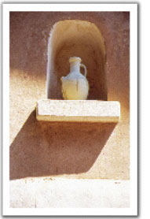  Even if you don't plan on selling your photo to a magazine, make every effort to keep it balanced and beautiful. On one level or another, everyone responds better to a picture that has all elements in balance. Strive to lead the eye along an interesting path through the photo, with the use of strong lines or patterns.
- Keep the horizon level
- Crop out extra elements that you are not interested in (more on this is the next tip)
- Consciously place your subject where you think it most belongs rather than just accepting it wherever it happens to land in the photo
- Play with perspective so that all lines show a pattern or lead the eye to your main subject
- to keep the picture exiting: do not always keep the subject in the middle of the photo.
4. Be selective | 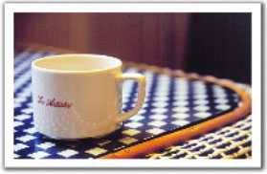  Decide what you are really interested in and centre your efforts on getting the best photo of this subject, whether it is an animal, person, mood, culture, etc. Along these lines, be sure to keep anything that would distract out of the picture: remove unwanted elements. The easiest way to do this is to watch your borders and recompose if anything - such as an unattractive telephone wire, an old soda can, a distracting sign, or your finger - hangs into your picture.
TIP | 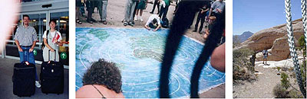  Watch out for fingers and camera straps! :-) Don't do like this:
5. Look at the light |   By this, I don't mean look into the sun - no, that won't do at all. But it is good to see what kind of light you are working with. Which way are the shadows falling? Unless you want a silhouette effect, where your subject is black against an interesting background, it's generally best to shoot with the sun behind you. How is the light affecting your subject? Is the light blazing directly and brightly upon your whole subject? Side lighting, on the other hand, can add drama but can also cause extreme, hard-to-print contrasts. Lastly, indirect light can be used to make your subject glow soft and pretty.
6. Be bold | Don't allow yourself to be paralysed by fears about correct film, correct settings, or correct social policy. If you are afraid of upsetting someone by taking their picture, just go up and ask if it's okay. Ask them to sign a release and offer a print in return. Be wise... but be bold.

