0/3 - Computer Skills: MS Word

HANDOUT: MS WORD

The best way to get to know the MS Word program is behind a screen: learning by doing. If you want to understand the concept of MS WORD, you can read this metaphor for MS Word.

Handout: an artist as a metaphor for MS Word

An artist as a metaphor for MS Word
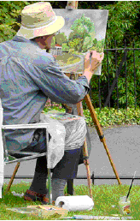
Do you see his painting? That is his creation. We make a text in MS Word as our creation.

The painting is placed on a canvas, a piece of textile mounted on a wood, to carry the paint properly. Our painting will be called a document in MS Word and the canvas is our window.

Do you see the pallet on his knees? This is where he will mix the colours, all different attributes and features for him to choose from. The paint he chooses from his pallet is placed on his canvas by means of pencils and brushes. These are the painter’s tools. We also have tools in MS Word.

So MS Word is also a way of supplying us with a canvas, tools and a pallet to create a document. The computer can save this for you or send the file to the printer so you will finally have a piece of paper with your creation. Do you recognize the similarity between the painter and MS Word?

