0/2 - Computer Skills: Files and Folders, the Keyboard

HANDOUT: THE KEYBOARD
This handout tells you the basics about the computer keyboard layout. The first figure shows the layout of the average keyboard. A keyboard is one of the ways to tell the computer what to do. Other devices that can be used for doing so are a mouse (painting) and a joystick (games).

A keyboard is most useful when typing texts. Not all keyboards have the same layout. The keyboard in the figure below is generally used in English-oriented countries. It is called a ‘QWERTY’ keyboard. Can you figure out why? French-speaking countries have another layout: ‘AZERTY’. This can be really confusing if you are not used to it! In some parts of the world, they have keyboards that we cannot even understand because not everybody uses the same characters that we know (think of Russia or China).
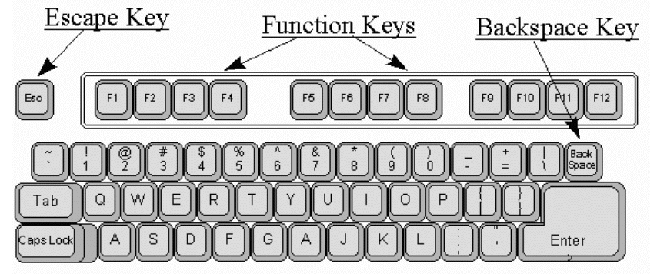

Besides the character keys, there are many other keys. The following figure shows you some of them:
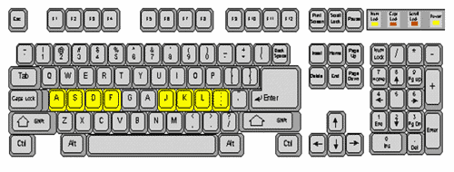

Which key has which function?

ESCAPE KEY
Use this key to get you out of situations you do not want to be in. Press this key to quit any task you are performing.

FUNCTION KEYS
Twelve keys that perform predefined tasks that differ from application to application. These keys allow to you perform specific tasks quickly.

BACKSPACE KEY
Use this key to remove the character to the left of the cursor. The backspace key should be used to correct mistakes.

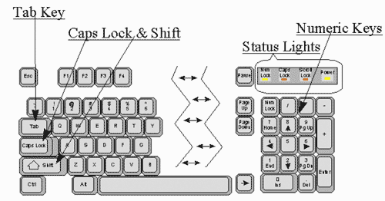

STATUS LIGHTS
Indicate whether the numeric and capital letter features are on or off. Scroll lock is not used on PCs anymore.

NUMERIC KEYS
With 'num lock' on, you can use the numeric keypad to enter numbers. When the 'num lock' key is off, you can use the keys marked with an arrow to move the cursor up, down, to the right and to the left.

TAB KEYS
The tab key moves the cursor from one data entry field to the start of the next data entry field. If there are multiple data entry fields on the same line, the tab key will always move you from left to right and from top to bottom. The back tab key (shift + tab) moves the cursor to the start of the previous data entry field. It moves you from right to left and from bottom to top.

CAPS LOCK AND SHIFT KEYS
These keys allow you to enter data in upper and lower case letters. A caps lock status light on indicates upper case letters, and a caps lock status light off indicates lower case.
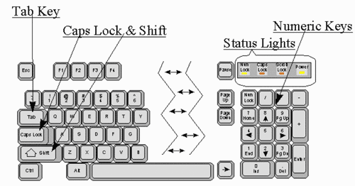

ENTER AND RETURN KEYS
Words typed onto a computer behave differently from words written on paper: when the words get to the end of a line, they start on the next line without being asked. This is called word wrap. The end of a line made this way is called a ‘soft return’. To make a line finish before it gets to the end, press one of the ENTER keys. They are on the right hand side of the keyboard. On the far right is one marked ‘Enter’. On the right of the main block of keys, there is a large key with a bent arrow. This is also an ENTER key. A line end that is made by the ENTER key is called a ‘hard return’.

Fast typing
To be able to type fast and with more than one or two fingers at the same time, you have to know some tricks. The following text describes the basics of typing with ten fingers on the keyboard.

To type with ten fingers, you have to know the 'home keys': these are the keys on which your fingers (five on your left hand and five on your right hand) rest when not typing. The home keys are A, S, D and F (left) and J, K, L and ; (right). Most keyboards have a small ridge indicating the home keys positions; check this.

First, gently rest your left little finger on the ‘A’ key and your right little finger on the ‘:’ key. Rest your other fingers (except thumbs) on the next closest keys. In other words, for your left hand, the ring finger goes on ‘S’, the middle finger on ‘D’ and the forefinger on ‘F’. For your right hand, the ring finger rests on ‘L’, the middle finger on ‘K’ and the forefinger on ‘J’.
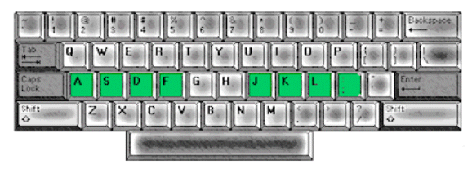

Your thumbs should rest on the space bar (the long, thin key at the bottom of your keyboard). The letters ‘G’ and ‘H’ should still be visible, untouched, at the centre of the keyboard. This is your resting or default finger position. Whenever a finger is not typing another character, it should return to its default position. It is not necessary for a finger to actually touch its default key, but it should at least return to a position above it.

Many keyboards have a ridge on the ‘F’ and ‘J’ keys (the keys your forefingers rest on). This is intended to help you find your default position without having to stop and look at your hands. Another way to do this is to locate your ‘Shift’ keys and find your place in relation to them. On most keyboards, the ‘Shift’ keys are a unique shape.

Before we move on to actually typing anything, take some time to practise finding your default position without having to look at your hands. Once you feel comfortable with this, you are ready to move to the next step.

Now, try typing the alphabet. At first, of course, you will have to look to see where everything is, but keep practising until you can do this while looking at your monitor instead. Then try doing it with your monitor turned off. Do not forget: whenever a finger is not typing, it should return to its default position

Next, go through the same steps you did for the alphabet for numbers 1 through 10. Try going from 10 to 1 as well. Once you are comfortable with number keys, practise using your punctuation keys. Look to see where they all are, then try typing each one with your eyes closed, starting from your default position. Do this ten times for each character. Some punctuation marks require the use of a ‘Shift’ key.

We mentioned the ‘Shift’ keys earlier. You may already know that you need to press the ‘Shift’ key if you want to produce a capital letter or the upper character on a key. What many people seem to forget is that there are two shift keys. You should use the right shift key when typing with your left hand and vice versa, so you do not try to press two keys with one hand at the same time.

Try typing the words of your favourite song or poem in all capital letters (known as ‘caps’), but do it using your shift keys rather than your ‘Caps Lock’ key. Do not forget punctuation! Next, try to do the same thing using proper capitalization.

